## Need help to make a complaint?

#### You can ask for more support.

**You can get help from:**

**CORAS** — Colac Otway Regional Advocacy Services.

You can call their office on **5232 1009**

You can visit their office at 50A Rae Street, Colac.

## or

**Villamanata Disability Rights Legal Services.**

You can call their office on **1800 014 111**

You can visit their office at 1 Gheringhap

Street, Geelong.

## You can also talk to the

#### National Disability Insurance Scheme, Quality and Standards Commission

For NDIS Funded Clients

**Making a complaint is OK**

Freecall (from landlines): **1800 035 544**

TTY: **133 677**

National Relay Service ask for **188 035 544**

Website: [http://www.ndiscommission.com.au](http://www.ndiscommission.com.au/)

**Transport Accident Commission** Phone: **1300 654 329** or **1800 322 556** (toll free outside Melbourne)

Email: [complaints@tac.vic.gov.au](mailto:complaints@tac.vic.gov.au)

## or

### **Valid —** Victorian Advocacy League for individuals with Disability Inc.

You can call their office on **9416 4003**

You can visit their office at 235 Napier Street,

Fitzroy.

#### Victorian Disability Worker Commission

Phone:**1800 497 132**

Website: [www.vdwc.vic.gov.au](http://www.vdwc.vic.gov.au/)

**Disability Services Commissioner (DSC)**

For DFFH and TAC Funded Clients Phone: **1800 677 342**

Email: [complaints@odsc.vic.gov.au](mailto:complaints@odsc.vic.gov.au)

# How to make a complaint at Colac Otway Disability Accommodation

**Inc.**

## What is a complaint?

A complaint is where you have a problem that you want to get fixed.

You tell someone about your problem.

It might be a problem with:

* The CODA service you receive.
* Someone at CODA.
* Something else about CODA.

If you are unhappy you can make a complaint.

You will always be treated with fairness and respect if you make a complaint about our service.

CODA welcomes complaints so they can improve their services to meet the needs of the community.

CODA will respond to a complaint you make within 3 working days and attempt to resolve the matter within 6 working days.

## How to make a complaint



**ok**

**I’m not happy with CODA**

* + Talk to your support worker.
  + Write a note and give it to your support worker.
  + Ask someone you know to tell the

support worker or supervisor.

* + Make a call to the CODA office.
  + Send an email.
  + You can make a complaint without giving your name. You can do this by a letter or an advocate.

## Can you ask someone to help you with a complaint ?

Yes, you can ask someone to help you with

a complaint. You can ask anyone including:

* + Someone from your family
  + An Advocate
  + A friend
  + A staff member

## Who can you complain to?

Your program Supervisor A Support Worker

The Quality and Compliance Manager

Phone: 5231 1573

CODA

Email[: coda@coda.org.au](mailto:coda@coda.org.au)

You can visit the CODA office at 58 Hesse Street, Colac.

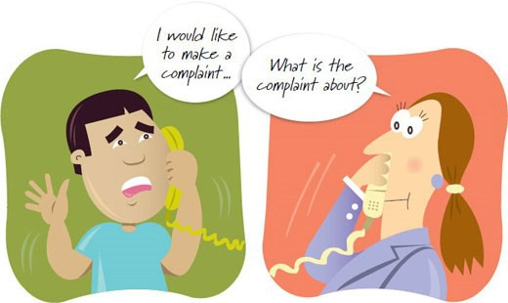

## For further help...

If your complaint is not fixed, you can talk to someone else.

Details of who to contact can be found on the back of this brochure.